Irah Shaikh
Spring 2024
GEOG 375

Data Centers in Sacramento: Final Report

SUMMARY

With the launch of ChatGPT in 2022 one can safely conclude that the tech space has changed in a manner that is irreversible. Within a week of its release more than 1 million users had already interacted with the model, Big Tech took note and announced future plans to implement genAI in its software, and critics rose from the depths of seemingly nowhere and everywhere all at once (Fried). Three years later it’s clear genAI is going nowhere, it is now a widely used alternative to commonplace search engines such as Google and is now deemed as the crux of any form of success within the tech field.
As an environmentalist and artist, my relationship with ChatGPT (and broadly genAI) is a resistant one. I can see its benefits in some areas — such as how it is a crucial aid for small business and underpaid teachers, but the cons far outweigh these arguments for me. And although I can go on as to why I am not a fan, the one I will focus on is its environmental impact.
Where there is a question prompted to ChatGPT there is a backend of high-level processing we are unaware of, and if we are, we are unable to process it to its true extent ourselves. AI applications are complex and generate plenty of heat 24/7, thus the data centers at which information is processed require several cooling systems and water. Generating a 100-word email “[o]nce requires 519 millimeters of water” which accounts to roughly a bottle of water, that may not seem like a lot but it’s 10 times more than Google (Verma). And querying an email once a week for a year will add up to 1.5 cooler jugs (Verma). To put that further into perspective “[i]f 1 in 10 Americans used ChatGPT weekly for a year, it would require the amount of water equal to that used by the entirety of Rhode Island — for 1.5 days” (Verma). And “...should demand for AI systems double in 2026, it would equal roughly the amount of electricity used by Japan” (Garrison).
That number is large…and what is worse is that means water must be reallocated, and in areas where water is scarce, such as in California, a wilde-fire prone state that is seemingly always in a drought, this is a case of great concern. Furthermore, those who live near these data centers face the worst of consequences. Such as nonexistent water pressure in homes resulting in non-flushable toilets and sinks, and the bare trickles of water that are available being filled with sediment from data centers (“I Live…”). To higher electricity bills for neighboring civilians, forcing them to pay for the operational costs produced by data centers rather than the data centers paying it themselves (“I Live…”).
For this reason I wanted to see how many data centers exist in Sacramento (and where they exist) in order to gauge if there are any trends on where they are located. This was done by first gathering all the data centers in Sacramento on an excel sheet and joining it to a parcel layer from the County. From there a query was done to process where the join key was the same. Afterwards several queries and geoprocesses were done to isolate and display relevant data from select feature layers which were then exported as PDFs.

PURPOSE
Environmental injustice is something I grew aware of within college, and as someone who identifies with several marginalized communities myself, striving for equality has always been on my agenda. After coming back from college with a deeper knowledge on how to identify environmental injustice it was hard to ignore how prevalent it was in Sacramento. A large example of such being the Urban Heat Project offered from the Sacramento Metropolitan Air Quality Management District which depicts increased levels of heat nearest to highways, which tend to be bordered by lower-income and non-white communities (Junghans). These communities also have less access to green spaces and are located near waste disposals, toxic storage units, and coal-fired power plants (Junghans). I wanted to see whether data centers could be added to this list.

DESCRIPTION OF TASKS
Acquiring Data
The first order of business was gathering my data. Information on where data centers are located is accessible at datacentermap.com, however they had replied quite late in terms of receiving a shapefile for data centers in Sacramento. For this reason I decided to gather information on the data centers on an excel file and then gecoding it. I forgot that geocoding the information requires credits, so I decided my next order of business was attaching it to an existing shapefile. I decided to use a shapefile I had on hand which was the Sacrament County Parcels shapefile (accessible via Sac County GIS Portal).
I wanted to compare the data center data in relation to the SACOG Blueprint - as they evaluate data from various federal, state, regional, and local entities while also considering financial, growth, and regulatory constraints to determine the community type of certain areas. His way I could determine if there were specific communities that data centers tend to be in.
I also wanted to compare the data to census data, specifically against race groups to see if there was a correlation between where the data centers are and marginalized communities. I gathered this data from the SACOG GIS portal.
Geoprocessing Tasks
Part One: Prep the Workspace
- First I opened up a project in ArcGIS Pro so I had something to call when creating paths in my script. I created an alternative geodatabase in which I wanted my data to be opened up into. And a second geodatabase for my output files. I also uploaded my data center excel sheet and uploaded it as a working table in Pro.
- I created a workspace in my script—this would be the location from which all my variables and original data was stored and pulled from. I made sure the workspace is the geodatabase I created in Pro. I also created an outpath for all my output files (to my new .gdb called “fgdb1.gdb”).
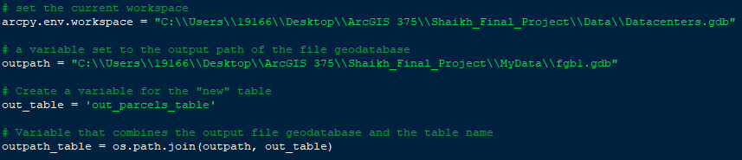
- I also created a variable for the new table I planned to load in the data center data into as well as parcel data. I also created variables which are to be used in the MakeFeatureLayer, MakeTableView, and the AddJoin and RemoveJoin routines.
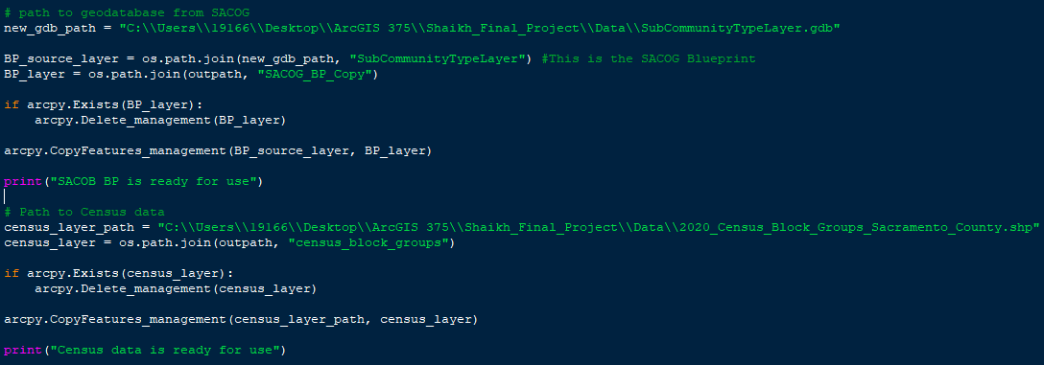
- I also had to create a path to the SACOG geodatabase since the shapefile I wanted to use resided in it. From there I pulled the shapefile from the SACOG geodatabase and pulled it into my working geodatabase. I also made sure that if my census and SACOG layers already existed that they were deleted.

Part Two: Prep the Data Center Data
- First I made sure if the table exists that it’s deleted. Once that was ensured I used CreateTable to create the new table. The location of both is the “fgdb1.gdb”.
- I added the fields I want to tack onto the table. These are based on my excel sheet. I also created a list of the fields as that is what would help me loop through the cursor.
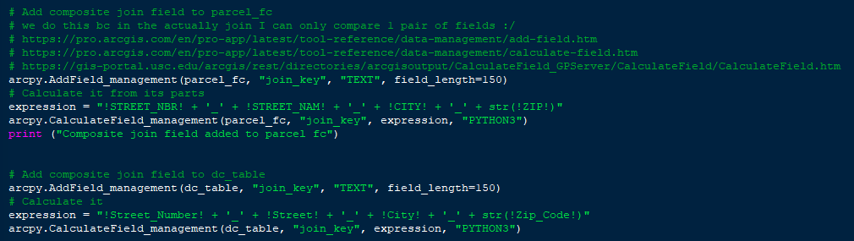
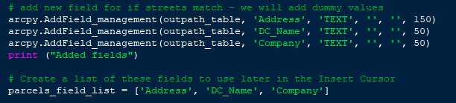
- So for my data center table and the census data the address was split between several fields (Number, Street, City, Zip Code). But when you are doing a join it is only done by a single field. For this reason I had to add in an extra step in which I created a composite join field. This will ensure that the streets are all one field.
- Now I used the MakeFeatureLayer routine to create a feature layer from the parcel layer. And then I used the MakeTableView routine to create a table view from the data center table.
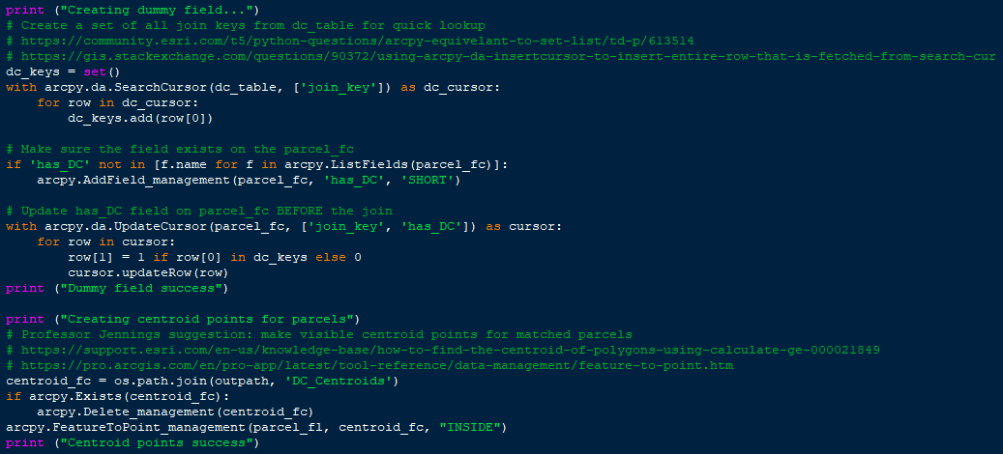
- I then wanted to create a dummy field in which if the address matches you get a “1” and if not then “0”. I did this using the UpdateCursor routine. I will use this field to display data centers in my maps. I also wanted this field to be displayed as points so I used arcpy.FeatureToPoint_management routine to ensure that occurred.
- Finally, the AddJoin routine is used. the feature layer and table view and the following fields and use ‘KEEP_ALL’ for the Keep All parameter. The Parcel feature layer variable (parcel_fl), the data center table view variable (dc_tv), and the address– key field in both layer and table.
- Now I added in an InsertCursor so that the table is referenced. This way a single record will be read and will lead to insertion new data where data does not exist later.
- A SearchCursor is then prepped by creating a field list, then a query statement, and variables where values will be stored
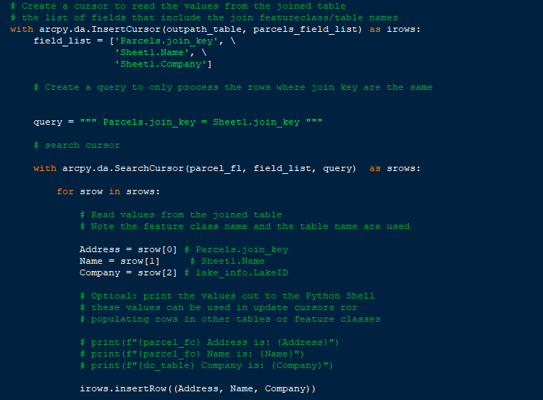
- Finally I used insterRow to insert variables made in Search Cursor that were read.
- I also then remove the join.
Part Three: Prep the SACOG Map
- I made sure all the layers I want to use are visible in my table of contents, but not checked/visible. And I also make sure I have a map layout opened up. In my layout tab I add in the Map Tile, Date text, and Legend - and adjust the title for all as needed so I can call them in my script.
- I defined my file management variables: ppath - Pro project path, mappath - Output location for PDFs, arpx - Pro project file. Earlier I had defined a date with the line: CUR_DATE = datetime.date.today().strftime(‘%m.%d.%Y’) so that it prints the date the script is run. I added my SACOG layer.
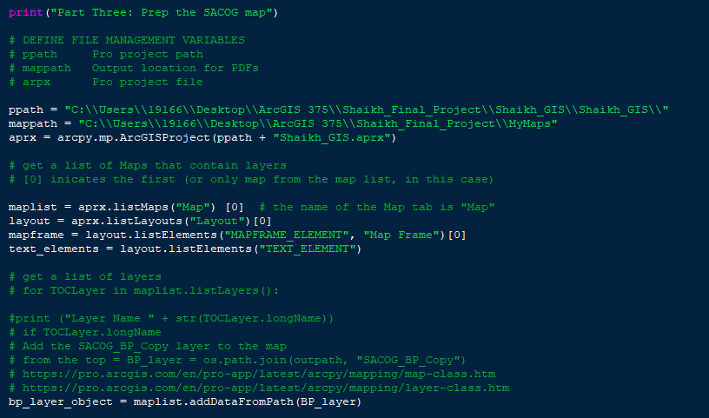
- I then use hasattr to adjust the symbology to create a map with unique values based on fields.
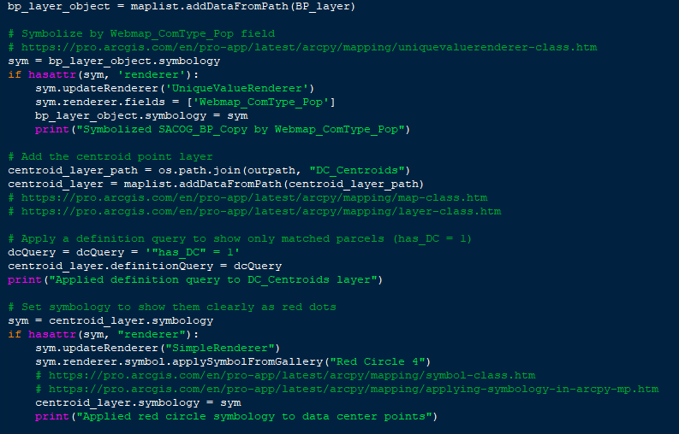
- I then add my data center layer, and use a query to only show parcels with the dummy field count equal to 1 (data centers present). I also update the symbology for this layer.

- I use the moveLayer routine to ensure the data center layer is the one on top. And then setExtent routine to ensure the focus is on Sacramento only.
- Then I created a loop to alter text elements within the Pro project. I used the if else statement because I only had two text boxes to work with.
- Then the map is ready to be exported. First if the PDF exists it must be deleted.
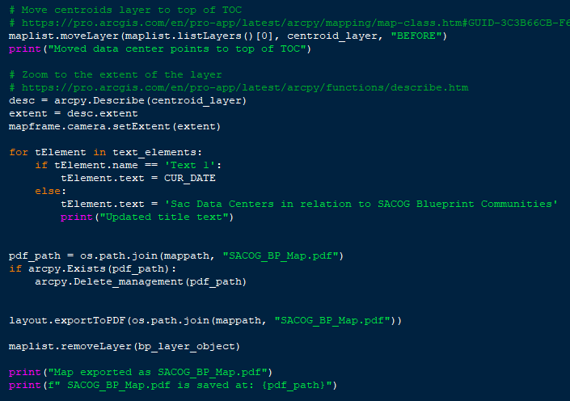
Part Four: Prep the Census Maps
- Same as before, I made sure all the layers I want to use are visible in my table of contents, but not checked/visible. And I also make sure I have a map layout opened up. In my layout tab I add in the Map Tile, Date text, and Legend.
- I defined my file management variables: census_layer_object, sym_census, text_elements1.
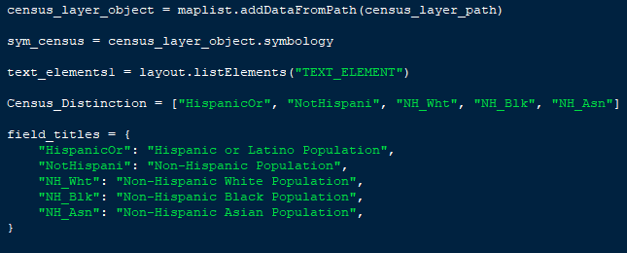
- I created a list of all the fields I wanted to cycle through for the maps I want to make. I also added code to rename them for when I make the maps.
- I then created a for loop which included geoprocessing for how the census layer would be displayed, and assembly pertaining to text elements.
- I use the moveLayer routine to ensure the data center layer is the one on top. And then setExtent routine to ensure the focus is on Sacramento only.
- Then I created a loop to alter text elements within the Pro project.
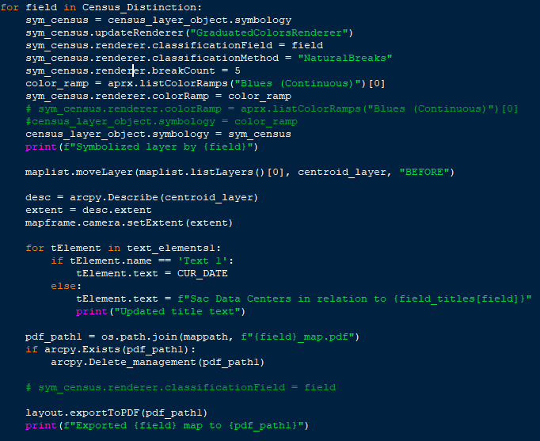
- Then the map is ready to be exported, again first if it exists/then delete code is also used.

SUMMARY OF ISSUES
I was able to get my script to run successfully, but in order to do so it did take a lot of editing and streamlining.
Data Center Verification
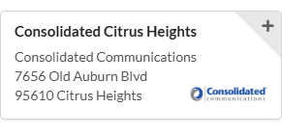
First issue I came to was the fact that some of the addresses from datacenters.com weren’t up to date. I went through and double and triple-checked all the data centers to ensure the addresses were correct. An example below depicts how the street name was incorrect.

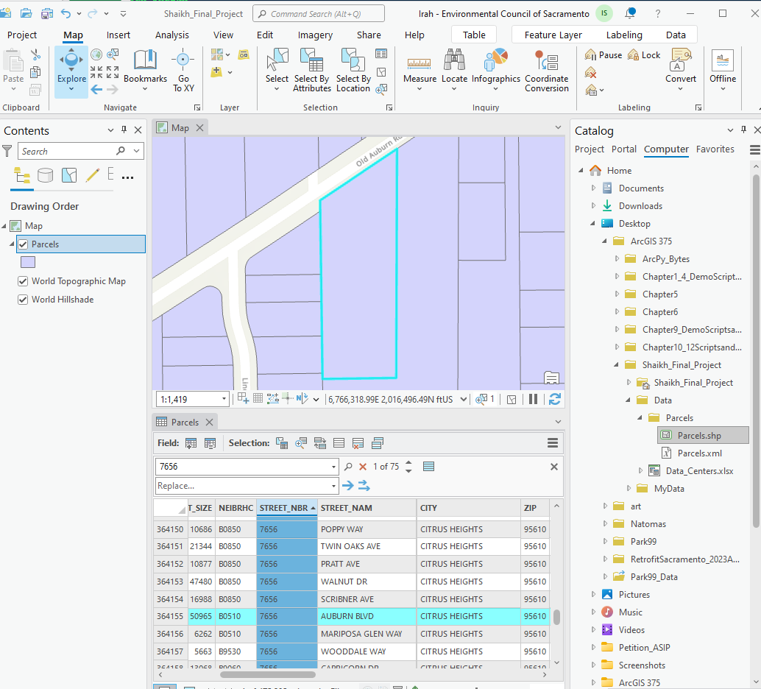

ExceltoTable
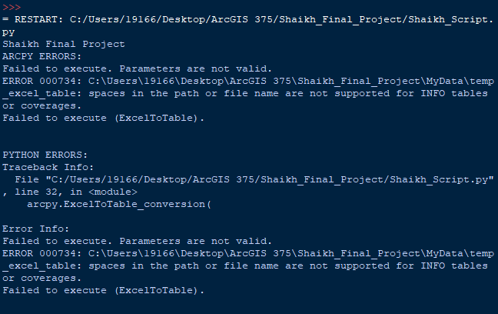
Most of the work I have done on Pro is with .shapefiles, so I haven’t had to upload and work with excel tables too much. For this reason I was unsure what to do what I ran my code and got the following error:
I realized it was because Pro can’t work with excel files so I had to go into pro and open the table up and save it to a geodatabase.

Multiple Joins
My next issue pertained to when I was attempting to join my parcel and data center data. The addresses were split between multiple fields however arcpy.AddJoin_management() only supports joining a single field unlike what can be done in SQL. For that reason I created a composite join field to make addresses a single field.
Dummy Field
Creating a dummy field was actually kind of hard and I had to do a lot of research and troubleshooting in order to word my Update/Search Cursor correctly to loop through my empty field. I decided to use the set() command because that would help create a list of all values from the join_key field in the dc_table. The SearchCursor routine then iterates through the rows.
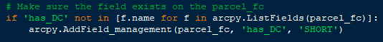
The above lines took me a bit to work up. But with my old Python notes on nesting statements and looking through discussions I was able to come to an understanding that if I first worked on a for statement breaking down LIST ROUTINE >> FIELD>> NAME OF FIELD then I could place that in an if statement. This then iterated through all the values to make sure they had an empty dummy field called ‘has_DC’ in short integer form.
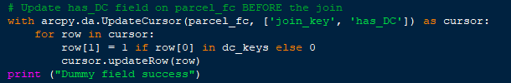
Finally I had to populate the field with ones and zeroes. I used UpdateCursor to loop through each parcel feature. Row[0] was the parcels join key, and row [1] was in the DC_field. If there was a match between the parcel join key and dc_key then a 1 was populated, if not a 0. I was able to nest in an if statement here to make the code cleaner too.
Map Production
Finally I had some issues with my map production. For example when I ran the script my SACOG layer was shown twice in the TOC because I hadn’t ensured it wasn’t visible before running the script. Or my text hadn’t updated and it was because I hadn’t called my text in its for loop with the proper title in the Pro Layout tab - I had to go in and adjust the titles from what was automated there already so it could properly be called when the script ran.
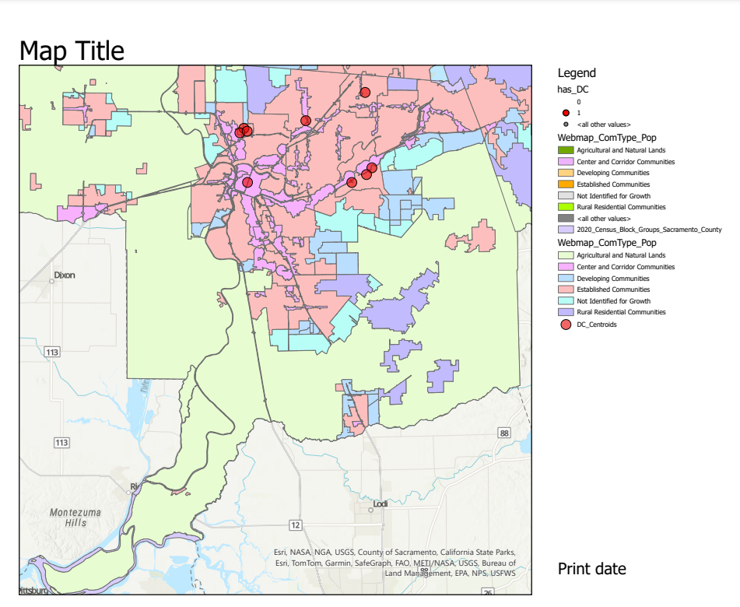
For my Census Data map my issues were fixed by simply indenting everything beck into my for loop which I had overlooked.
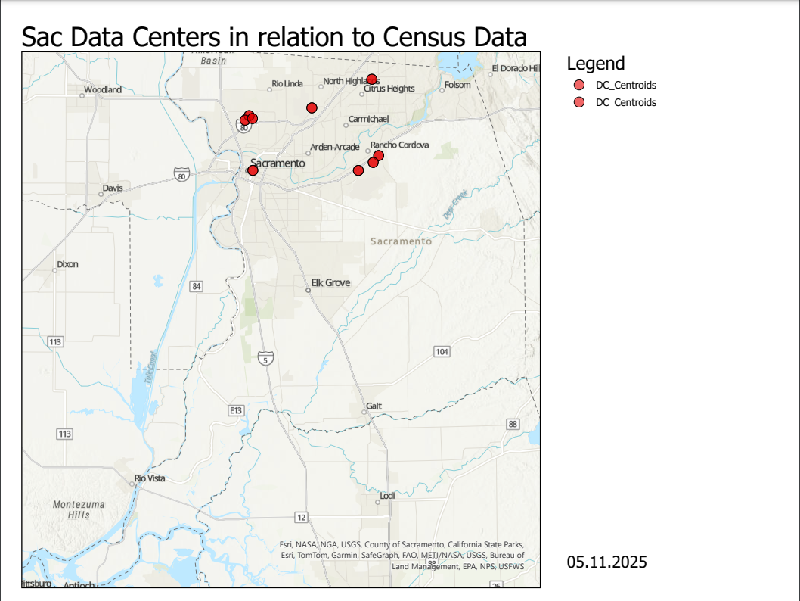

If I had more time I would have tried to figure out how to select the colors for my unique values for my SACOG map. I would have also liked to create another map using income from the Census data. I was using the Census Tract data for Sac provided from SACOG and I would have had to download another shapefile, clip it to the Sac region, and then create a whole separate map for it - and for some reason I can’t download this specific file. I could probably find a way to get it straight from the census bureau, but I would need some time to familiarize myself with the site again and how to find the specific data which I just didn’t have the time for.
I also would have also normalized my population data, as Sacramento is predominantly white and this skews data for marginalized communities (i.e. black communities which are the minority of the mentioned races). Before is from the Census Bureau.
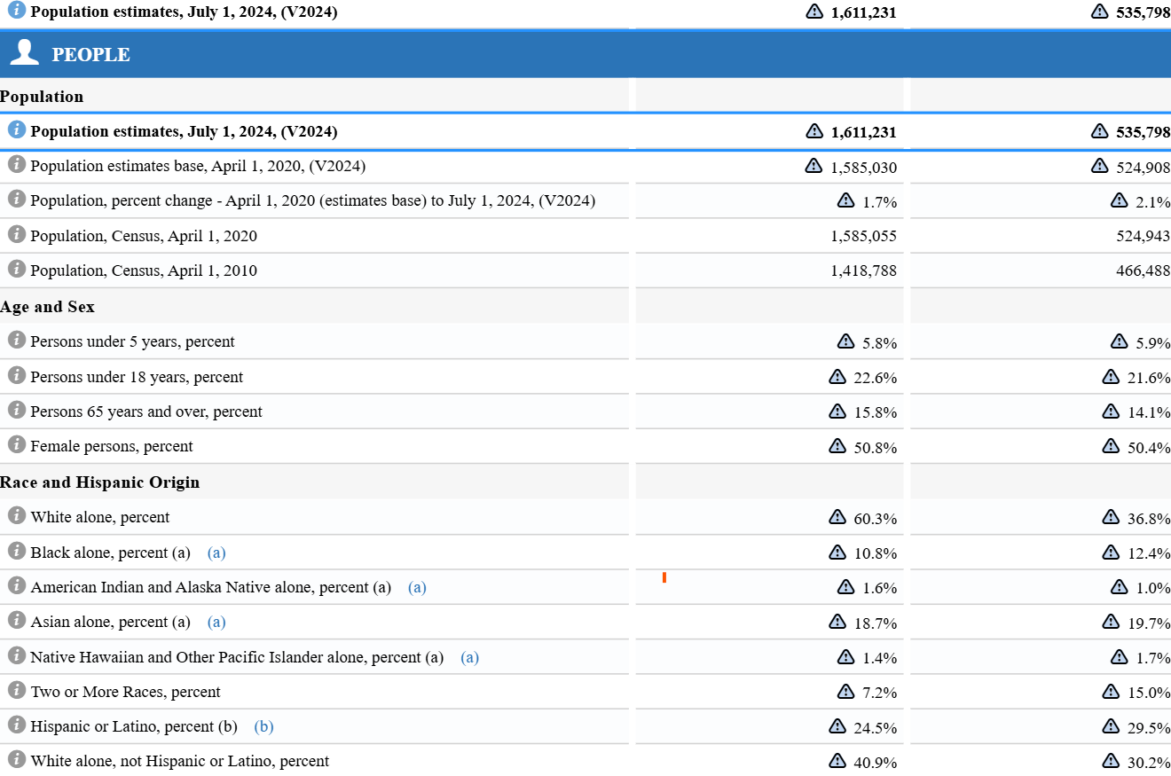
LEARNING OUTCOME
Prior to this class I had a beginner level understanding of Python which I hadn’t brushed up on for a couple years and absolutely no idea on how to apply it to ArcGIS. But with this class I feel as though I am much more confident with using Python in relation to Pro. Creating layers, uploading/joining data, running queries, using cursors, and creating maps are all something I feel confident in and I also have enough working knowledge on them that I can identify where I can use Python to help streamline mapmaking at my workplace.
With the final project I have learned how to take the information we learned from class and then adjust it here and there to address the ways our data may different from the data we used in our assignments. It also helped me grow more comfortable with working through errors in my script.
Additionally, my findings suggest (this is a very surface level connection I am making here) that data centers are situated primarily in Center and Corridor Communities and near Established Communities.
SACOG identifies the former as “ typically higher density and more mixed than surrounding land uses. Centers and Corridors are identified in local plans as historic downtowns, main streets, suburban or urban commercial corridors, rail station areas, central business districts, or town centers. They typically have more compact development patterns, a greater mix of uses, and a wider variety of transportation infrastructure compared to the communities surrounding them” (“2025 Blueprint”). While “Established Communities are typically the areas adjacent to, or surrounding, Center and Corridor Communities. Many are characterized as “first tier,” “inner ring,” or mature suburban communities. Local land use plans aim to maintain the existing character and land use pattern in these areas” (“2025 Blueprint”).
This does seem to make sense as projects not pertaining to housing are more likely to be approved in these mixed use communities rather than in communities primarily meant for agriculture and residential use.
When we look at the Census maps which distinguish areas by race the following was noted:
 | White | Asian | Black | Hisp/Latino | Non Hisp
Natomas | Not affected | Affected | Affected | Affected | Affected
Downtown | Not affected | Not Affected | Not Affected | Not Affected | Not Affected
Rancho Cordova | Affected | Affected | Somewhat Affected | Affected | Affected
Citrus Heights | Affected | Not Affected | Somewhat Affected | Affected | Affected

From this visual summation it can be suggested that data centers are located in areas where there are larger colored populations and therefore impact these communities more. Hispanic /Latino communities are impacted the most while white communities are impacted the least.
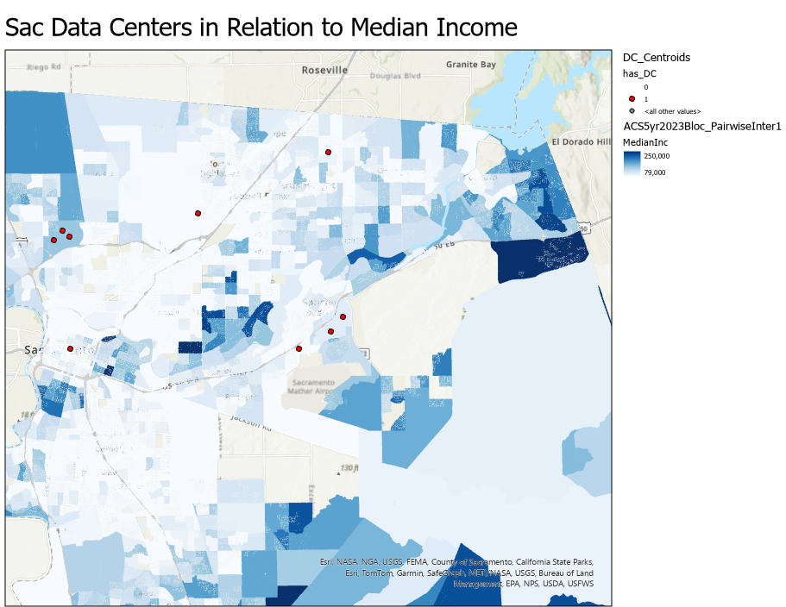
Although I could node add in the code for median incomes as discussed earlier I was able to open the data in Pro and create this map just out of curiosity:

Based on this we can also say lower income areas are chosen for the establishment of data centers.
Natomas seems to be an outlier in terms of income, however it is important to note that the area is less congested in relation to the other incorporated cities and for that reason is probably easier to establish data centers in. It also has the largest minority populations compared to other cities.

Works Cited
“2025 Blueprint Pathway Land Use Evaluation Update | SACOG.” Sacog.Org, 2 Feb. 2024, www.sacog.org/planning/2025-blueprint/blueprint-land-use/2025-land-use-news-updates/2025-blueprint-pathway-land-use-evaluation-update-258.
Fried, Ina. “OpenAI’s CHAT GPT Has Evolved Insanely Fast in One Year.” The Technology behind ChatGPT Is Evolving Insanely Fast, 28 Nov. 2023, www.axios.com/2023/11/28/chat-gpt-one-year-anniversary-ai.
Garrison, Anna. “How Does Ai Use Water and Energy? Unpacking the Negative Impact of Chatbots.” Green Matters, Green Matters, 10 Jan. 2025, www.greenmatters.com/big-impact/how-much-water-does-ai-use.
“I Live 400 Yards From Mark Zuckerberg’s Massive Data Center.” YouTube, More Perfect Union, 27 Mar. 2025, youtu.be/DGjj7wDYaiI?si=4QN-QMMDUwuZnaL4.
Junghans, Jennifer. “Understanding Environmental Justice in Sacramento.” Solving Sacramento, 6 May 2024, solvingsacramento.org/understanding-environmental-justice-in-sacramento/.
Verma, Pranshu, and Shelly Tan. “A Bottle of Water per Email: The Hidden Environmental Costs of Using AI Chatbots.” The Washington Post, 18 Sept. 2024, www.washingtonpost.com/technology/2024/09/18/energy-ai-use-electricity-water-data-centers/.

