Memorandum
To: Sacramento County Planning Commissioners
From: Irah Shaikh, GIS & Administrative Support, Environmental Council of Sacramento
Date: November 2025
Subject: Regional Growth and Housing Suitability Analysis for the Sacramento Region

Purpose

This analysis evaluates regional housing development trends and buildout potential within Sacramento County and its incorporated jurisdictions. The objective was to determine the extent to which current and proposed projects align with Regional Housing Needs Allocation (RHNA) goals, income distribution targets, and sustainable growth strategies outlined in local general plans.

Methods

Data were collected from multiple public sources, including:
- Parcel, zoning, and land use datasets from the City and County of Sacramento
- Project information and FEIRs for more than 25 large-scale developments
- HCD RHNA data for the 6th cycle
- SACOG Blueprint and growth projections (2020–2050)

All data were integrated into ArcGIS Pro for geospatial analysis. Parcel-level data were filtered to isolate land zoned for development, and project-level information (such as acreage and total housing units (HU)) was extracted from land use data and corroborated by FEIRs and general plan documentation. RHNA data were cross-referenced to evaluate affordability distribution and regional housing balance.

Key Findings

Buildout Progress: Of approximately 33,000 acres of development approved by SACOG in the Sacramento region, representing 171,000 total planned housing units, only 42% of projected construction is expected to be complete by 2050.

Income Distribution: Most units, in progress or built, serve moderate to high-income households. Projects targeting very low and low-income groups are substantially underrepresented.

Development Pattern Observations: Roughly one-third of all new development is occurring on Greenfield sites. This a major increase from 4% in 2020 and indicates a regional shift away from infill priorities.

Performance by Jurisdiction: While the City of Sacramento demonstrates higher completion rates (80–100%) for projects such as Northlake and Delta Shores, unincorporated county areas average only 10–28% progress, with several large master-planned communities remaining unbuilt.

Policy Implications: This uneven progress suggests that existing growth patterns are unlikely to meet RHNA affordability targets and may exacerbate infrastructure and environmental costs associated with sprawl.

Implications for Regional Planning

The findings highlight the need for local governments and planning agencies to prioritize infill development and direct future housing allocations toward lower-income affordability goals. Increased reliance on Greenfield expansion risks further delaying existing projects, straining public services, and reducing regional resilience under CEQA sustainability objectives.

This analysis supports ECOS’s ongoing advocacy for compact growth, transit-oriented development, and equitable housing distribution within the Sacramento region. Continued monitoring of buildout progress and RHNA compliance will be essential to guide policy and community engagement moving forward.

Below are visuals representing these findings.

In 2050, almost half of these entitled Greenfield developments will remain to be built.
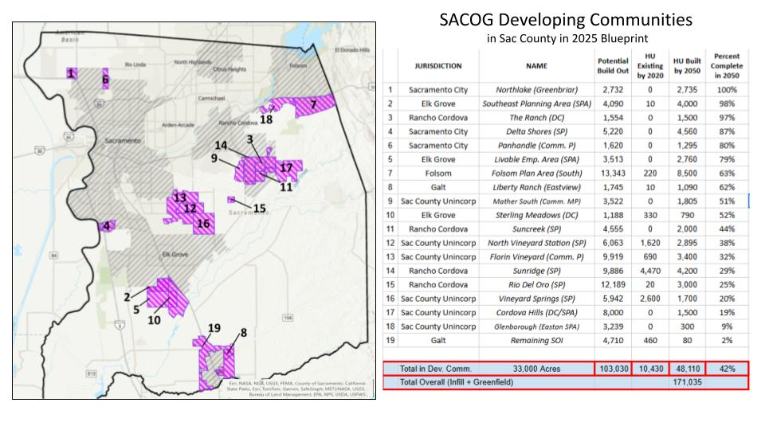
In addition to the nearly 50,000 housing units (HU) still unbuilt in 2050 (approved by SACOG BP), the County has the potential to build out another 93,935 HU. The County does not have an accurate build out estimate available, as some projects have not been approved.
Notes: Developments accounted for in SACOG Blueprint are highlighted in blue in the table below. Unassigned Sacramento County developments are for commercial use.
